**Engineering Test Procedure (ETP):**

**(Flammable Vapors Ignition Resistance)**

|  |  |
| --- | --- |
| **Test Condition 1: Main Burner Operation** | Continuous pilot |
| **Test Condition 2: Main Burner Cycling** | Electronic ignition (no standing pilot) |
| **Test Condition 3: Standby** | Continuous pilot |
| **Test Condition 4:** | Electronic ignition (no standing pilot) |

**Product Setup:**

1. Install product/spill gas as shown in Figure 14:
2. Install Hydrocarbon sample tubes in locations 1-4 as shown in Figure 17.
   1. Lowest point in front of the water heater, on the side of the jacket not less than 2 inches from the floor.
   2. On the front of the water heater at a midpoint of the floor to jacket top height.
   3. On the rear of the water heater at the midpoint of the floor to jacket top height.
   4. On the top of the water heater’s jacket.
3. Place “Flue Sample Tube” into flue exhaust and connect to Siemens Ultramat 23 CO/CO2 Analyzer
4. Install venting as shown in Figure 17

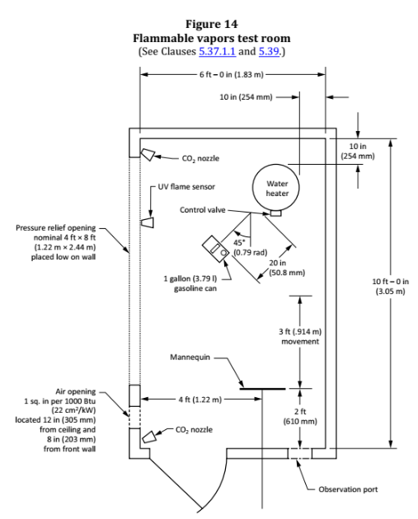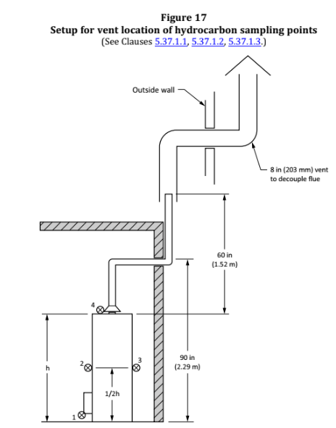

1. The water heater shall be tested with all access doors in their normal position. If the lighting instructions call for the opening or removal of any doors to light the pilot and if the main burner will operate with those doors removed or opened, the tests shall be repeated with the removable doors removed and sliding or hinged doors left in a fully open position unless self-closing.

**Test Setup (Before Test Start):**

1. Determine test to be run (Test Condition 1, Test Condition 2, Test Condition 3, or Test Condition 4)
2. Determine gasoline type to be used (Summer or Winter Blend)
3. Temper gasoline to 70 ± 2 ºF.
4. Transport gasoline to the AP2 Engineering Burn Room Lab for Reid Vapor pressure reading
   1. Summer Blend Reid Vapor Pressure ≤ 8 PSI
   2. Winter Blend Reid Vapor Pressure ≥ 13 PSI
5. Place gasoline can into tipping device as shown in figure 15.
   1. Winter Blend Gasoline Tips **TOWARD** the water heater
   2. Summer Blend Gasoline Tips **AWAY** from water heater

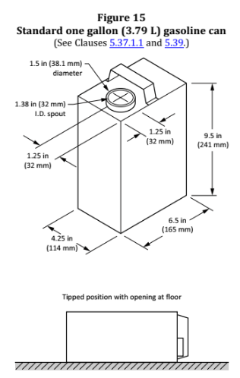

1. Fill water heater with 70 ± 2 ºF water
2. Set thermostat to 120 ºF
3. Perform the ANSI 15 Minute Rate Test at normal inlet test pressure (AFCO shall not exceed 0.04%)
4. Remove Flue Sample Tube from product exhaust
5. Verify ambient temperature inside of the room at start of test is 75 ± 5 ºF
6. Verify the main burner on the water heater is “ON”
7. Press “Start” on the automated software

**Test End**

1. Fill water heater with 70 ± 2 ºF water (Only if capable)
2. Set thermostat to 120 ºF (Only if capable)
3. Export the **starting** ANSI 15 Minute Rate Test to a text file
4. Perform the ANSI 15 Minute Rate Test at normal inlet test pressure (AFCO shall not exceed 0.04%) (Only if capable)
5. Export the **ending** ANSI 15 Minute Rate Test to a text file
6. Robocopy Full LDO Test Data to network.
7. Analyze Data Using the Water Heater Analysis Tool.
8. Submit Test Request for Engineering Review

Conditions to Stop the test

1. Water heaters burners have extinguished and there is no evidence of flame presence
2. The hydrocarbon concentration at all four sample tube locations are below 50% of the 1.8% lower flammability limit (LFL) of butane
3. The water heater has operated in a flammable vapor rich environment for a substantial period of time and in the judgment of the testing agency the water heater will not ignite flammable vapors if allowed to continue to operate
4. Ignition of flammable vapors has occurred outside the water heater